Pull request URL used to validate the workflows
https://github.com/HuntingEagle0/github-skills-challenge/pull/1
https://github.com/HuntingEagle0/github-skills-challenge/pull/2

Screenshot showing the GitHub Actions workflows
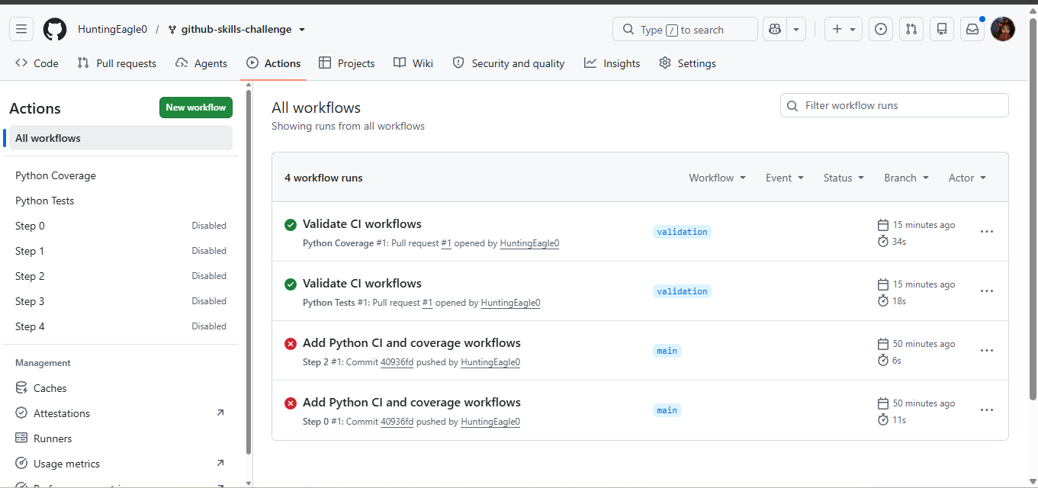
Screenshot showing a successful test workflow execution

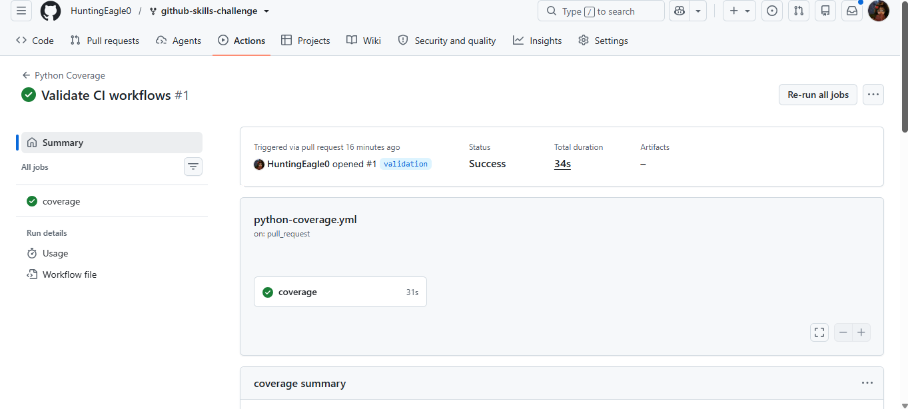
Screenshot showing the coverage result/comment on the pull request
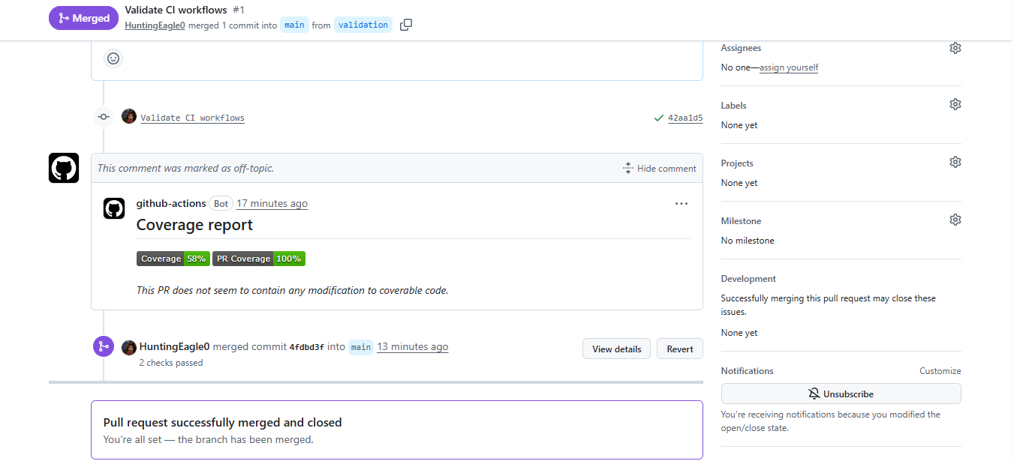
Screenshot showing the final repository/workflow files

